MEHRAN UNIVERSITY

OF ENGINEERING & TECHNOLOGY

JAMSHORO, PAKISTAN

Subject: Software Construction and Development

(Lab 3 - Tasks Solution)

|  |  |
| --- | --- |
| **Roll No:** | **22SW028** |
| **Section:** | **I** |
| **Name** | **Arbab Hussain** |

**LAB 03 TASKS (ACTIVITY DIAGRAMS)**

**NOTE: THE DIAGRAMS ARE CREATED WITH A WEB APP NAMED LUCIDCHART**

**Task1. (Without Swimlane)**:

Create an activity diagram for the Library Management System. Where inquiries regarding available books are made, the availability of specific books will be checked by the librarian if the book is not available the system will terminate the process. Afterward, the member’s validity was checked. This will be followed by checking the number of books assigned to the member as par quota. In case of all valid scenarios, the book will be issued by adding the member’s details with the book’s details. The status of the book will be updated. The system will go back to its initial state.

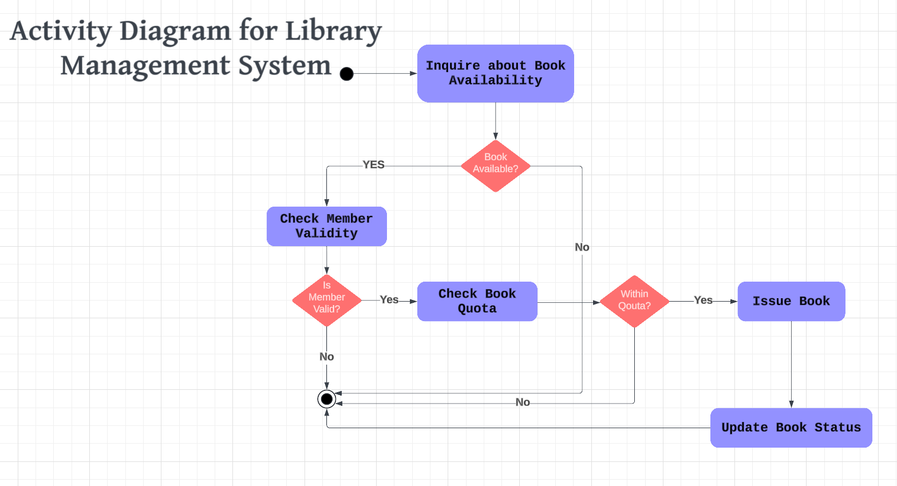

**Task 2. (Swimlane)**:

A Railway Reservation System that enables users to book train tickets online. The system allows users to select their preferred train, and travel class, and check seat availability. If the selected train and class are available, the user can proceed with the booking by making an online payment. The booking process involves several key stakeholders, including:

**Requester (User):** Initiates the process by submitting the train and class details.

**Booking Clerk:** Verifies the availability of seats or places the user on a waiting list.

**Bank Payment System:** Facilitates the online payment process.

The system should be capable of handling the following scenarios:

**Form Submission:** The user submits the train and class details. If the details are incorrect, the user is prompted to re-enter the information.

Seat Availability Check: If seats are available, the user can proceed with the booking and make online payment.

**Waiting List**: If seats are not available, the user is placed on the waiting list. Once seats become available, the user is notified and can continue the booking process.

**Payment Confirmation:** Upon successful payment, the booking is confirmed, and the user is provided with booking details. In case of unsuccessful payment, the user is asked to retry the transaction. The system should also maintain an updated list of available seats after every booking and notify users via SMS if they are on the waiting list and seats become available.

